
WM2U Make It Happen Fund – Strathmartine MIHF 2026
Information and Guidance for Applying

You can download a copy of the application form at:
https://wm2u.co.uk/strathmartine-make-it-happen-fund

1. Overview

The Strathmartine Make It Happen Fund

The Strathmartine Make It Happen Fund is run by local people for local people. The aim is to support and encourage local groups, by offering funding to them to support projects and initiatives that create positive change within their communities.

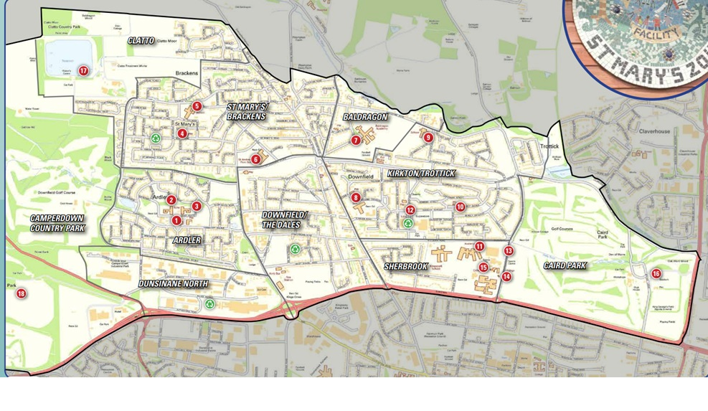
The money comes from the What Matters to You Make It Happen Fund in the Strathmartine ward. We have £30,000 available from this grants programme. The grants are administered by Corra, who are supporting the ‘Strathmartine MIHF’ to run the fund.

The ‘Strathmartine Makes It Happen’ group is made up of local people from Strathmartine ward who have come together to encourage community engagement to benefit the people of Strathmartine.

2. Drop-In Information Sessions in the area
You are encouraged to come for more information and help to fill out the form to a drop-in information session on either:

Friday 6th March from 1100 to 1300 at Ardler Complex, Turnberry Ave, Dundee DD2 3TP

You can collect a copy of the application form at the drop-in, or download from https://wm2u.co.uk/strathmartine-make-it-happen-fund



3. Aims of the fund

- To benefit and include the people of Strathmartine through:
  - Creating a safer and better environment.
  - Improving lives.
  - Enhanced and affordable opportunities.

  - To further the strategic outcomes of WM2U: services will learn about what individuals and communities can do for themselves and where services might better fit in the longer term, creating a new form of public service.


4. Who can apply?

The Strathmartine MIHF is open to Not-for-Profit organisations based in Strathmartine Ward, both constituted and non-constituted, whose activities are being delivered in Strathmartine Ward.

Organisations based in other parts of Dundee can apply where there is Children, young people & family voice from Strathmartine fully included in the planning and delivery of the activity.

- Applicant organisations/groups should have an annual income of less than £100,000.
- Groups must be not for profit. This means all money raised or earned is spent on the costs of providing current or future activities. The group/organisation can be:
  - formally constituted
  - informal unconstituted group.
  - The group/organisation should have at least three people on the committee/Board of Trustees, or for unconstituted groups, at least three people involved in organising it.
  - Community Interest Companies (CIC’s) must have three Directors where no one Director has significant control.
- Groups of young people (secondary school age and up to age 25) that are supported by a larger organisation but have a degree of independence. For example, where the group of young people make decisions on what to do and are instrumental in the running of those activities with some support.
- Clubs which run outwith school time and that are run by volunteers and where the Club is independent of the school.
- Groups run under a Local Management Group
- New grassroots unconstituted groups are very welcome.

We appreciate that many large organisations run groups in the community. The group itself could apply as an unconstituted group where:

It is independant, is responsible for raising its own funds and organising its own activities. The application must be in the name of the group and the contact person be an organising member of the group and not a staff member of a larger hosting organisation.

For applications from young people’s groups the contact person should be someone over 18 years. This may be a worker or volunteer who supports the group.

For example, a local authority nursery cannot apply. A group of parents from the nursery who wish to run an activity themselves, can apply. Similarly, Parent Councils of schools can apply to run activities themselves, but not to pass funding onto the school.

5. Who can’t apply

- Public bodies
- Projects of organisations where the organisation has income of over £100,000
- For profit organisations
- Applying on behalf of another organisation

6. What can be funded
The fund is to benefit the people of Strathmartine. It can be used to fund anything that helps the group/organisation to achieve the outcomes of the fund that may include but not restricted to:

- Materials to deliver activities
- Catering or food costs associated with activities.
- Room-hire costs.
- Equipment
- Travel costs to support with delivery of activities.
- Utility costs (heating/lighting)
- Expenses for supporting volunteers.
- Staffing costs
- Sessional delivery from organisations

Where equipment is funded, the equipment must remain in the Strathmartine area and in the ownership of the applicant group.

Those who applied before to the Strathmartine MIHF can’t apply for something that’s already funded. Only apply for what you need. And what can be spent within 12 months.

What CANNOT be funded?

- Items such as building projects, motor vehicles and refurbishment costs.
- Activities that have already happened or things already bought.
- Activities that are for the promotion, teaching, or worship practice of any faith.
- Activities that are for the promotion of anything political.
- Activities and statutory services of public bodies such as hospitals and medical centres, schools, universities, and colleges.
- Overseas trips
- Applying to pass funding on to or buy things for another organisation.

7. How much can be applied for?



There is a maximum of up to £2,000 per application.

The Grant can be used for full project funding or part project funding where the balance of funds has already been secured, under application, or towards general running costs of existing activities.
The grants will be available from May 2026 and therefore applications should not be made for activities happening before May 2026.

8. Writing your application
Thinking about your project:
- What will change because of the project and who will benefit?
- How does the project benefit the people of Strathmartine through:
  - Creating a safer and better environment.
  - Improving lives.
  - Enhanced and affordable opportunities.
- How many people will take part?
- What do you need to run your project and what does this cost?



9. Where and when to send your application

Send your application by 5PM on Friday 27th March by email to Hazel Feilder hazel.feilder@dundeecity.gov.uk or hand in to one of the following Community Centres in a sealed envelope for attention of Hazel Fielder.
- Ardler Complex, Turnberry Ave, Dundee DD2 3TP
- St Marys Community Centre, St Kilda Rd, Dundee DD3 9NH
10. How will decisions be made?
The Strathmartine Makes It Happen group will
- consider which applications fit the guidelines.
- invite those that best fit to an event on 1st May (this event must be attended).
- Invite each group under consideration for funding to share their project idea with the Strathmartine MIHF group and other applicants in person.
- Give feedback to those that don’t fit.



11. Award Conditions

- Allocated funds must be spent within one year of receipt. Funds cannot be spent before a grant is allocated and can only be spent as outlined in the grant application.
- Groups may be asked to undertake free safeguarding training where appropriate.
- Instructions/conditions for claiming awarded grants will be sent with award letters along with any other conditions.
- If invited to the event on 1st May a representative must attend, to qualify for a grant
- Groups should maintain records of income and expenditure and receipts for purchase made.

12. How will the money be paid?
- Corra Foundation are handling the administration and payment of the grant.
- The grant will be paid in one instalment into the bank or credit union account of the group.
- If the group does not have a bank account, we can pay the grant into the account of another group (Buddy Group) which agrees to hold the money for you.

13. What happens after?
We want to hear how you’re getting on with your project.

- We plan to visit projects to find out how things are going
- We ask that you collect photos, video, art and stories from the community participants and your own learning, to show the activity and the difference it made to people.

You can collect a copy of the application form at the drop-in, or download from https://wm2u.co.uk/strathmartine-make-it-happen-fund

What Matters to You is supported through a partnership between The Hunter Foundation and BBC Children In Need. The Make It Happen Fund is part of the What Matters to You approach with funding from BBC Children in Need, The Hunter Foundation, Northwood Charitable Trust, The Robertson Trust and William Grant Foundation


The Corra Foundation is a charity registered in Scotland (No SC009481) and is also a company limited by guarantee (No SC096068).

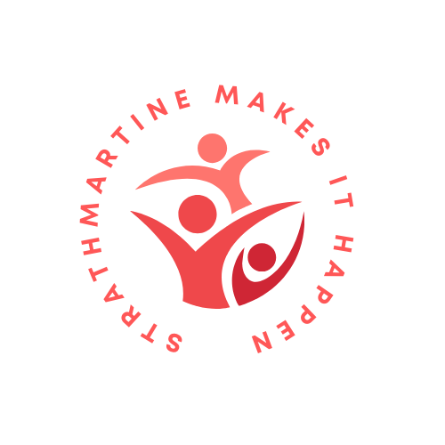

Strathmartine Makes It Happen is a group of parents recruited from Strathmartine ward who have designed, developed and are the community voices that make decisions on the funding distributed by What Matters to You via The Corra Foundation.

