
WM2U Make It Happen Fund – Lochee Takeover
Information and Guidance for Applying

You can download a copy of the application form at:
https://wm2u.co.uk/lochee-make-it-happen-fund

1. Overview

The Lochee Make It Happen Fund

The Lochee Make It Happen Fund is run by local people for local people. The aim is to support and encourage local groups, by offering funding to them to support projects and initiatives that create positive change within their communities.

The money comes from the What Matters to You Make It Happen Fund in the Lochee ward. We have £8,000 available from the second round of this grants programme. The grants are administered by Corra, who are supporting the ‘Lochee Takeover’ to run the fund.

The Lochee Takeover is a group made up of local people from Lochee ward who have come together to encourage community engagement to benefit children, young people, families and adult groups in the Lochee Ward.

2. Drop-In Information Sessions in the area
You are encouraged to come for more information and help to fill out the form to a drop-in information session:

Monday 21st July from 10am/mid-day at Menzieshill Community Centre, 260 Dickson Ave, Dundee DD2 4TQ

You can collect a copy of the application form at the drop-in, or download from https://wm2u.co.uk/lochee-make-it-happen-fund



3. Aims of the fund
- To benefit Children, young people, families & adult groups in the local community.
- To create and deliver the impacts that you (Children, young people families, & adult groups) want to see in your communities.
- To further the strategic outcomes of WM2U: services will learn about what individuals and communities can do for themselves and where services might better fit in the longer term, creating a new form of public service.


4. Who can apply?

The Lochee MIHF is open to Not-for-Profit organisations based in Lochee Ward, both constituted and non-constituted, whose services are being delivered in Lochee Ward.

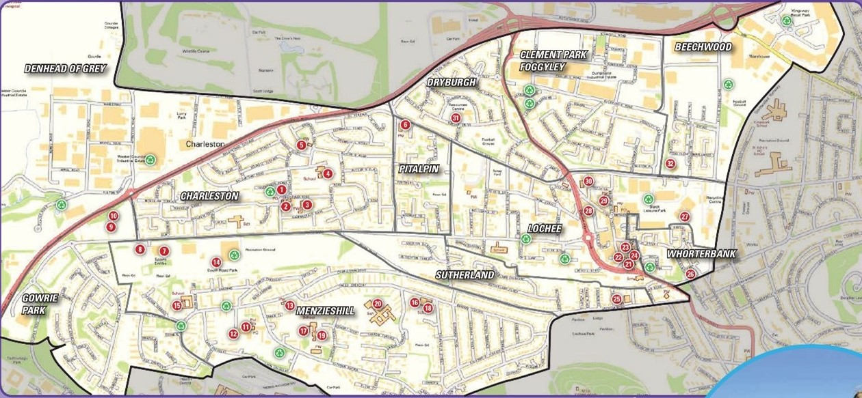

Organisations based in other parts of Dundee can apply where there is Children, young people & family voice from Lochee fully included in the planning and delivery of the activity.

- Applicant organisations/groups should have an annual income of less than £20,000.
- Groups must be not for profit. This means all money raised or earned is spent on the costs of providing current or future activities. The group/organisation can be formally constituted, or informal unconstituted group with at least 3 people on your committee/Board of Trustees/Directors/unconstituted group?
- Groups of young people that are supported by a larger organisation but have a degree of independence. For example, where the group of young people make decisions on what to do and are instrumental in the running of those activities with some support.

5. What can be funded?
The fund is to support activities to benefit, children, young people, families or Adult Groups in the Lochee Ward. A project might be a one-off event, or a series of activity sessions. We are keen to encourage new ideas. Funding can be used for the following but not restricted to:

- Materials to deliver activities
- Catering or food costs associated with activities.
- Room-hire costs.
- Equipment
- Travel costs to support with delivery of activities.
- Utility costs (heating/lighting)
- Vouchers for supporting volunteers.
- Sessional delivery from organisations

7. How much can be applied for?
There is a maximum of up to £1,000 per application.

The Grant can be used for full project funding or part project funding where the balance of funds has already been secured, under application or towards general running costs of existing activities.



What CANNOT be funded?

- Major items such as building projects, motor vehicles and refurbishment costs.
- Salary costs.
- Activities that have already happened or things already bought.
- Activities that are for the promotion, teaching, or worship practice of any faith.
- Activities that are for the promotion of anything political.
- Mainstream activities and statutory services of public bodies such as hospitals and medical centres, schools, universities, and colleges.

For example, a local authority nursery cannot apply. A group of parents from the nursery who wish to run an activity themselves, can apply. Similarly, Parent Councils of schools can apply to run activities themselves.

8. Writing your application
Thinking about your project:
- What will change because of the project and who will benefit?
- How does the project support children, families, young people or adult groups.
- How many people will take part?
- What do you need to run your project and what does this cost?



9. Where and when to send your application

Send your application by 5pm Friday 15th August by email to LocheeMIHF@whatmatters2u.org.uk or hand in to one of the following Community Centres in a sealed envelope.

- Charleston Community Centre, 66 Craigowan Rd, Dundee, DD2 4NL
- Menzieshill Community Centre, 260 Dickson Ave, Dundee, DD2 4TQ
- Lochee Hub, Highgate Centre, 118 High St, Dundee, DD2 3BL

10. How will decisions be made?
The Lochee Takeover group will
- consider which applications fit the guidelines.
- invite those that best fit to an event in August.
- Invite each group under consideration for funding to share their project idea with the Lochee Takeover group and other applicants in person.
- Give feedback to those that don’t fit.



11. Award Conditions

- Allocated funds must be spent within one year of receipt. Funds cannot be spent before a grant is allocated and can only be spent as outlined in the grant application.
- An organisation cannot make an application within twelve months of receiving its most recent funding from the MIHF
- Groups will be asked to undertake free safeguarding training.
- Instructions/conditions for claiming awarded grants will be sent with award letters along with any other conditions.
- If invited to the event in August, applicants or a representative must attend, to qualify for a grant

12. How will the money be paid?
- Corra Foundation are handling the administration and payment of the grant.
- The grant will be paid in one instalment into the bank or credit union account of the group.
- If the group does not have a bank account, we can pay the grant into the account of another group (Buddy Group) which agrees to hold the money for you.

13. What happens after?
We want to hear how you’re getting on with your project.

- We plan to visit projects to find out how things are going
- We ask that you collect photos, video, art and stories from the community participants and your own learning, to show the activity and the difference it made to people.

You can collect a copy of the application form at the drop-in, or download from https://wm2u.co.uk/lochee-make-it-happen-fund

What Matters to You is supported through a partnership between The Hunter Foundation and BBC Children In Need. The Make It Happen Fund is part of the What Matters to You approach with funding from BBC Children in Need, The Hunter Foundation, Northwood Charitable Trust, The Robertson Trust and William Grant Foundation

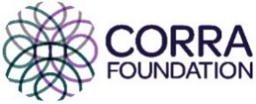
The Corra Foundation is a charity registered in Scotland (No SC009481) and is also a company limited by guarantee (No SC096068).

The Lochee Takeover is the group of parents from Lochee ward who have designed, developed and are the community voices that make decisions on the funding distributed by What Matters to You via The Corra Foundation.

