**WM2U, Make It Happen Fund –Hillfoots MIHF**

**Information and Guidance for Applying**

**You can download a copy of the application form at:**

<https://wm2u.co.uk/make-it-happen-fund>

**1. Overview**

**The Hillfoots Make It Happen Fund**

The Hillfoots Make It Happen Fund is run by local people for local people. The aim is to support and encourage local groups, by offering funding to them to support projects and initiatives that create positive change within their communities, to the benefit of children and families.

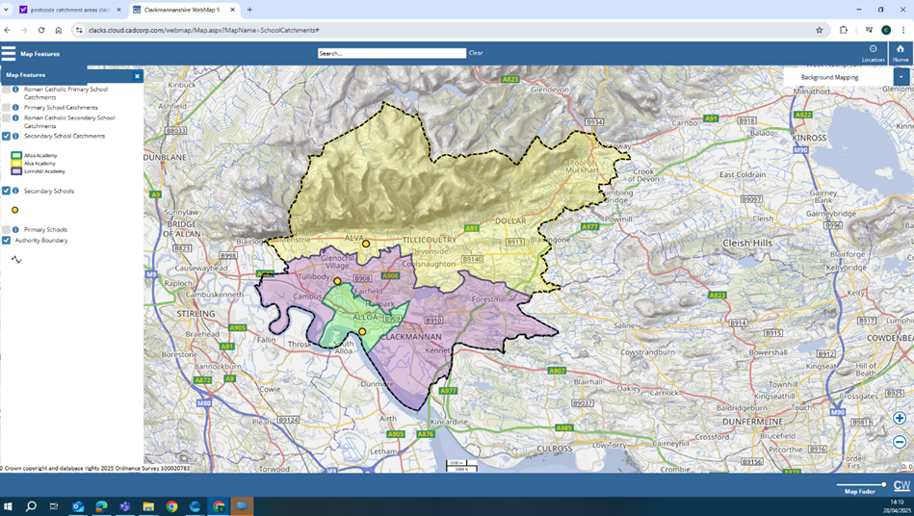

The money comes from the What Matters to You Make It Happen Fund in the Hillfoots area.

**We have £10,000 available from this grants programme for funding of activities from January 2026. Applications are now open and will close on 10 October 2025**. The grants are administered by Corra, who are supporting the ‘**Hillfoots Make it Happen ’** to run the fund.

The ‘**Hillfoots Makes It Happen’** Panel is made up of local people recruited from the Hillfoots who have come together to encourage community engagement to benefit the people, children and families of the Hillfoots.

**2.** **Drop-In Information Sessions**

You are encouraged to come for more information, advice or support to fill out the form to a drop-in information session on either:

* **Tuesday 16th Sep 2025 at 10 a.m. – 12 noon Cochrane Hall, The Cochrane Hall Park, Alva, FK125LJ**
* **Thursday, 25th September 7 - 8.30 pm Coalsnaughton, Village Hall, 30 Main Street, Coalsnaughton.**

You can collect a copy of the application form at the drop-in, or download from <https://wm2u.co.uk/make-it-happen-fund>



**3. Aims of the fund**

Promoting inclusion and improving the lives of children, young people, parents, families, carers of young people and young carers of the Hillfoots by:

* Building on Community Spirit, bringing community members together to make a change in their communities and sustain groups to benefit the Hillfoots community.
* Providing affordable, subsidised, or free opportunities and experiences.
* Using the information from applications, the Panel will help inform planning for future funding and services for families in the Hillfoots.



**4. Who can apply?**

The Hillfoots Make it Happen Fund is open to Not-for-Profit organisations based in the area of the Hillfoots, both constituted and non-constituted, whose services are being delivered in and benefit the Hillfoots area.

Organisations based in other parts of Clackmannanshire can apply where there is children, young people & family voice from the Hillfoots fully included in the planning and delivery of the activity, as long as the service is delivered in the Hillfoots area for the Hillfoots.

* Applicant organisations/groups must have an **annual income of less than £50,000 as noted in their most recent approved accounts.** We don’t expect new groups to have annual accounts, but should have an expected income of under £50,000.
* Groups must be **not** for profit. This means all money raised or earned is spent on the costs of providing current or future activities. The group/organisation can be formally constituted, **or** an informal unconstituted group and must have at least 3 people on your committee/Board of Trustees/Directors or for an unconstituted group, involved in the organising A social enterprise or Community Interest Company must have at least 3 Directors none of which has significant control, and should also have an asset lock.
* Groups of young people that are supported by a larger organisation, this means with an annual income over £50,000, but have a degree of independence. For example, where the group of young people make decisions on what to do and are instrumental in the running of those activities with some support.

**5. What can be funded?**

The fund is to **benefit children, families, parents, carers of young people and young carers of the Hillfoots area.** It can be used to fund costs linked to activities that help the group/organisation to achieve the outcomes of the fund.

Types of activities ;

* Time limited activities
* One off event
* Day trips
* New or existing activities
* Where a club based in Hillfoots is for members only and the costs of being a member are making it difficult for local people to participate, funding can be used to enable local people to take part.

Types of costs

* Materials to deliver activities.
* Catering or food costs associated with activities.
* Equipment
* Travel costs to support with delivery of activities.
* Travel expenses for supporting volunteers.
* Sessional delivery from external organisations

6. **What CANNOT be funded?**

* Major items such as building projects, motor vehicles and refurbishment costs.
* General, regular running costs of existing organisations, such as rent, utilities or office costs
* Costs associated with gambling type activities
* Alcohol as refreshments
* Gala days
* Overseas trips
* Food Parcels
* **Cash or vouchers** for food, clothes or household bills.
* Salary costs or paying Directors of CIC’s for their work.
* Activities that have already happened or things already bought.
* Activities that are for the promotion, teaching, or worship practice of any faith.
* Activities that are for the promotion of anything political.
* Fundraising activities.
* Mainstream activities and statutory services of public bodies such as hospitals and medical centres, schools, universities, and colleges.
* More than one applications for teams that are part of the same club.

Some examples:

A local authority nursery cannot apply. A group of parents from the nursery who wish to run an activity themselves, can apply. Similarly, Parent Councils of schools can apply to run activities themselves, but not to pass money to the school.

A Community Interest Company (CIC ) cannot apply to pay its Directors to run an activity. If another organisation (which meets the criteria), wishes to engage the CIC to provide an activity for their organisation, then that organisation can apply for the costs of engaging the CIC.

A group cannot apply to give cash or vouchers to participants. But it can apply for the costs of providing equipment or uniforms for participants.

A football club which has multiple teams and each team runs itself but under the constitution of the club, can only apply once, providing it fits the income criteria. The individual teams cannot apply.

An existing organisation cannot apply for its regular core running costs such as office rent, utilities or salaries. It can apply for the costs of a new or existing activity or project. This might include venue hire, equipment, insurance. For example, an organisation runs several projects in the area. It has a small office with a part-time staff member. The activities are run elsewhere. The organisation cannot apply for the office costs or staff member. It can apply for costs of running the projects, such as venue hire, external tutors, materials.

**7. How much can be applied for?**

You apply on one occasion up to a maximum of up to £500 per application.

The Grant can be used for full project funding or part project funding where the balance of funds has already been secured.

**8. Writing your application**

Thinking about your project:

* What will change because of the project and who will benefit?
* How does the project benefit children, young people, families, parents, and carers of the Hillfoots?

9**. Where and when to send your application**

**Completed Applications should be returned no later than Friday 10th October at 5 p.m.**

Applications should be emailed to [jane@whatmatters2u.org.uk](mailto:jane@whatmatters2u.org.uk)

**or**

returned by hand to *one* of the following locations in a sealed envelope addressed to Jane Carter, What Matters to You, The Hillfoots Make It Happen Fund to the

* Cochrane Hall, The Cochrane Hall Park, Alva, FK125LJ or
* Coalsnaughton, Devonside and Langour Village Hall, 30 Main Street, Coalsnaughton, Clackmannanshire, FK136JH

**10. How will decisions be made?**

The Hillfoots Make It Happen Panel will:

* consider which applications best fit the guidelines.
* ask for more information if required to make a decision.
* give feedback to those that are not successful.

**11. Grant Conditions**

* Allocated funds must be spent within one year of receipt. Funds cannot be spent before a grant is allocated and can only be spent as outlined in the grant application.
* If you do not have a safeguarding policy and appropriate checks for staff and volunteers, this needs to be in place before the activity starts. Here are some useful resources. [https://scvo.scot/support/running-your-organisation/safeguarding](https://eur03.safelinks.protection.outlook.com/?url=https%3A%2F%2Fscvo.scot%2Fsupport%2Frunning-your-organisation%2Fsafeguarding&data=05%7C02%7Cjane%40whatmatters2u.org.uk%7C0cb8d4b4efe5461fb59908dde08b818a%7C73c4cbfeaa824c558d05196185602593%7C1%7C0%7C638913611984227943%7CUnknown%7CTWFpbGZsb3d8eyJFbXB0eU1hcGkiOnRydWUsIlYiOiIwLjAuMDAwMCIsIlAiOiJXaW4zMiIsIkFOIjoiTWFpbCIsIldUIjoyfQ%3D%3D%7C0%7C%7C%7C&sdata=Yw4OiG5VXvcUtvKPJgktJB%2B46nrTSCqAo1D7x%2B%2F%2B1EY%3D&reserved=0); [https://www.volunteerscotland.net/disclosure-services](https://eur03.safelinks.protection.outlook.com/?url=https%3A%2F%2Fwww.volunteerscotland.net%2Fdisclosure-services&data=05%7C02%7Cjane%40whatmatters2u.org.uk%7C0cb8d4b4efe5461fb59908dde08b818a%7C73c4cbfeaa824c558d05196185602593%7C1%7C0%7C638913611984544099%7CUnknown%7CTWFpbGZsb3d8eyJFbXB0eU1hcGkiOnRydWUsIlYiOiIwLjAuMDAwMCIsIlAiOiJXaW4zMiIsIkFOIjoiTWFpbCIsIldUIjoyfQ%3D%3D%7C0%7C%7C%7C&sdata=aULc5eb%2BxzpLp3WaNM0IZX%2BSSrHPMCO86blBv1BhIHI%3D&reserved=0); <https://ctsi.org.uk/>
* Instructions/conditions for claiming awarded grants will be sent with award letters along with any other conditions*.*

**12. When will the money will be awarded and How?**

* Each organisation will be told the Panel’s decision by Friday 21st November.
* Corra Foundation are handling the administration and payment of the grant.
* The grant will be paid in one instalment into the bank or credit union account of the group.
* If the group does not have a bank account, we can pay the grant into the account of another group (Buddy Group) which agrees to hold the money for you.

**13. What happens after?**

We want to hear how you’re getting on with your project.

* The Panel will organise a celebration on Friday 21st Nov 6 p.m. – 8 p.m. at The Cochrane Hall, Alva for all organisations funded by the Hillfoots Make it Happen Fund.  We hope that all funded organisations will be able to send a representative.
* We plan to visit projects to find out how things are going.
* We ask that you collect photos, video, art and stories from the community participants and your own learning, to show the activity and the difference it made to people.

**You can collect a copy of the application form at the drop-in, or download from** <https://wm2u.co.uk/make-it-happen-fund>

What Matters to You is supported through a partnership between The Hunter Foundation and BBC Children in Need. The Make It Happen Fund is part of the What Matters to You approach with funding from BBC Children in Need, The Hunter Foundation, The Robertson Trust and William Grant Foundation

The Corra Foundation is a charity registered in Scotland (No SC009481) and is also a company limited by guarantee (No SC096068).

**The Hillfoots Makes It Happen** is a group of community members recruited from the Hillfoots area who have designed, *developed and are the community* voices that make decisions on the funding distributed by What Matters to You via The Corra Foundation.