
WM2U, Make It Happen Fund –Hillfoots MIHF
Information and Guidance for Applying

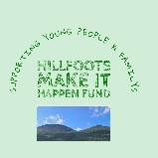

You can download a copy of the application form at:
https://wm2u.co.uk/hillfoots-make-it-happen-fund

1. Overview

The Hillfoots Make It Happen Fund

The Hillfoots Make It Happen Fund is to benefit the communities of The Hillfoots which include the villages of, Menstrie, Alva, Tillicoultry, Devonside, Coalsnaughton, Dollar and Muckhart.

The Hillfoots Make It Happen Fund is run by local people for local people. The panel of community volunteers have come together to encourage initiatives that create positive change by offering funding to existing and new groups.

The Hillfoots Make It Happen Fund is open to all groups, but priority will be given to those groups which benefit the lives of children, young people, parents, families, carers of young people, young carers who live in the Hillfoots area.
and particularly to new groups aiming to do this.

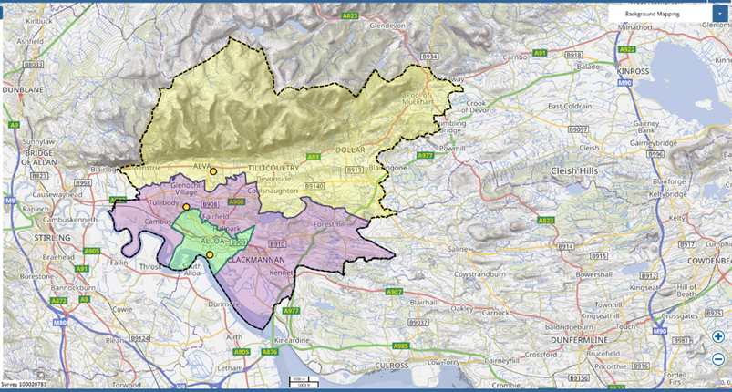

The money to make The Make It Happen Fund for communities in the Hillfoots comes from BBC Children in Need, The Hunter Foundation, The Robertson Trust, and The William Grant Foundation. The grants are administered by The Corra Foundation which support the Hillfoots Make it Happen panel to run the fund.

The Hillfoots Make It Happen Panel have £10,000 available from this grants programme for funding for groups and activities from July 2026 (subject to application process). Applications are now open and will close on Wednesday 29th April at 4 p.m.
If you want more information or need additional support, please contact.

jane@whatmatters2u.org.uk

or call or text Jane on 07501997346

Guidance and Application form can be found at

https://wm2u.co.uk/make-it-happen-fund

2. Do you need more Information or support?



3. Aims of the fund
Promoting inclusion and improving the lives of children, young people, parents, families, carers of young people and young carers of the Hillfoots by:

- Building on Community Spirit, bringing community members together to make a change in their communities and sustain groups to benefit the Hillfoots community.
- Providing affordable, subsidised, or free opportunities and experiences.
- Using the information from applications, the Panel will help inform planning for future funding and services for families in the Hillfoots.



4. Who can apply?

Your organisations/groups must have an annual income of less than £50,000 as noted in their most recent approved accounts.

We don’t expect new groups to have annual accounts, but you should have an expected income of under £50,000.

Organisations based in other parts of Clackmannanshire can apply where there are children, young people, and family voice from the Hillfoots fully included in the planning and delivery of the activity, as long as the service is delivered in the Hillfoots area for the Hillfoots.

The Hillfoots Make It Happen Fund is open to Not-for-Profit organisations. (This means all money raised or earned is spent on the costs of providing current or future activities).

The group/organisation can be:
- formally constituted
- existing or new informal unconstituted group. Please see further guidance below.
- The group/organisation should have at least three people on the committee/Board of Trustees, or for unconstituted groups, at least three people involved in organising it.
- Community Interest Companies (CIC’s) must have three Directors where no one Director has significant control.
- Groups of young people that are supported by a larger organisation but have a degree of independence. For example, where the group of young people make decisions on what to do and are instrumental in the running of those activities with some support. Please see guidance below.

Previous applicants can apply, but this should be for a new activity, or to fix a problem they didn’t have before. For example, now having to pay for hall hire. Priority will be given to new applicants.

The Hillfoots Make It Happen Fund would welcome applications from small groups that are currently running or wish to start activities in the Hillfoots. Applicants could apply for the costs of setting up a group, including running costs such as venue hire, insurance and PVG’s.

Some more guidance for unconstituted small groups

Adult’s groups:

We recognise that some small groups have been started by or are hosted by a larger organisation. Our principal is that groups should demonstrate independence from the larger organisation and ownership by the members of the group, developing its autonomy.

Groups which have been supported by a programme run by a larger organisation can apply where the group wish to keep meeting independently after the programme finishes. The application must come from the group and not the support worker from the larger organisation.

The funding could support the group to continue to meet beyond the programme where the group wishes to remain together and have a degree of autonomy.

For example, a group of parents who have been through a supported programme run by the Local Authority. The group of parents wish to continue to meet as a group for a craft and cuppa session which promotes wellbeing and peer support. The group is independent but the school-based family support or community learning development worker offers support if required.

Unconstituted young people groups:

Groups of young people (secondary school age and up to 26 years of age) that are supported by a larger organisation but have a degree of independence can apply.
.
The application must come from the young people and be about what they want to do not what the organisations wishes to do. Applications must have the voice of the group who are applying and be written by the group and not a worker. The key is it is not the organisation that is applying it is the group of young people.

The group of young people make decisions on what to do and are instrumental in the running of the activities with some support. If the group of young people are under the age of eighteen, then the application must be signed by the support worker.

5. Who can’t apply?
- Public bodies (schools, Community Development Teams, etc).
- Organisations or projects of organisations where the organisation has income of over £50,000.
- For profit organisations.
- A group applying on behalf of another organisation
- A youth group applying for a larger organisation and not themselves

6.What can be funded?
The fund is to benefit children, families, parents, carers of young people and young carers of the Hillfoots area. It can be used to fund costs linked to activities that help the group/organisation to achieve the outcomes of the fund.

Types of activities.

- New or existing activities.
- One off events and day trips where these are part of the ongoing group.

Types of costs
- Materials to deliver activities.
- Catering or food costs associated with activities.
- Equipment (Where equipment is funded, the equipment must remain in the Hillfoots area and in the ownership of the applicant group).
- Travel costs to support with delivery of activities.
- Travel expenses for supporting volunteers.
- PVG’s for volunteers
- Sessional delivery from external organisations
- Room hire

7. What CANNOT be funded?

- Major items such as building projects, motor vehicles, and refurbishment costs.
- Costs associated with gambling type activities
- Alcohol as refreshments
- Gala days
- Food Parcels
- Cash or vouchers for food, clothes, or household bills.
- Salary costs or paying Directors of CICs for their work.
- Activities that have already happened or things already bought.
- Activities that are for the promotion, teaching, or worship practice of any faith.
- Activities that are for the promotion of anything political.
- Fundraising activities.
- Mainstream activities and statutory services of public bodies such as hospitals and medical centres, schools, universities, and colleges.
- More than one application for teams that are part of the same club.
- For individual activities. For example, gym membership.
Or applying to pass funding on to or buy things for another organisation

Some examples:

A local authority school or nursery cannot apply. The funding cannot be used to replace statutory funding,

However, a group of parents from the nursery or school who wish to run an activity themselves, can apply. The group of parents may require a degree of support from a worker who may be employed by a local authority or other organisation.

Under funder’s rules activities that are for the promotion, teaching, or worship practice of any faith cannot be funded. However, a group of parents could apply for an activity that brought community together. The group could receive support where required by the family worker from the church. For example, to undertake an activity like a community garden or family cookery classes that provided new skills and connected people.

Similarly, Parent Councils of schools (primary and secondary) can apply to run activities themselves, but not to pass money to or buy equipment for the school. The parent council need to be involved in the activity (can work in partnership with the school) but the wish for the activity needs to come from the young people or parents themselves, not the school.

For example – the young people at the school expressed a wish to the parent council that they would like an outdoor garden. The Parent Council received a grant from the Make It Happen Fund for a polytunnel and equipment. The garden will benefit the wider community. The project belongs to the young people and the Parent Council who work in partnership with the school.

A parent council cannot apply to run a fundraising event and where there is a ticketed cost for entry fee.

A school cannot apply but a group of secondary aged young people (young people up to the age of 26) can apply where they have a degree of autonomy / independence to run the activity but have some support, if required.

A Community Interest Company (CIC) cannot apply to pay its directors to run an activity. If another organisation (which meets the criteria), wishes to engage the CIC to provide an activity for their organisation, then that organisation can apply for the costs of engaging the CIC. For, example to engage a local artist.

A group cannot apply to give cash or vouchers to participants. But it can apply for the costs of providing equipment or uniforms for participants.

A football club which has multiple teams and each team runs itself but under the constitution of the club, can only apply once, providing it fits the income criteria. The individual teams cannot apply.

8. How much can be applied for?
- The panel envisages making grants up to £500 but may on occasion increase this up to £1,000.

- The Grant can be used for full project funding or part project funding where the balance of funds has already been secured.



9. Writing your application
Thinking about your project:
- What will change because of the project and who will benefit?
- How does the project benefit children, young people, families, parents, and carers of the Hillfoots?



10. Where and when to send your application

Applications should be emailed to jane@whatmatters2u.org.uk

Completed Applications should be returned no later than 4 p.m. on 29th April 2026

If you require a paper application arrangement will be made through Jane to be collected at a pickup point.

Paper copies of the application and guidance can also be found and returned to any of the following named places.

- The Coalsnaughton, Langour and Devonside Village Hall.
- Dollar Community Development Trust, Park Place, Dollar
- Alva Development Trust, Cochrane Hall, Cochrane Park, Alva

11. How will decisions be made?

The Hillfoots Make It Happen Panel will:
- consider which applications best fit the guidelines.
- ask for more information if required to make a decision.
- give feedback to those that are not successful.

12. Grant Conditions

- Allocated funds must be spent within one year of receipt. Funds cannot be spent before a grant is allocated and can only be spent as outlined in the grant application.

- If you do not have a safeguarding policy and appropriate checks for staff and volunteers, this needs to be in place before the activity starts. Here are some useful resources. There is help available.
- https://scvo.scot/support/running-your-organisation/safeguarding; https://www.volunteerscotland.net/disclosure-services; https://ctsi.org.uk/

- Instructions/conditions for claiming awarded grants will be sent with award letters along with any other conditions.

13. When will the money will be awarded and how?
- Each organisation will be told the Panel’s decision by email by Tuesday 2nd June.

- Save the date. There will be a celebration event for those organisations that best fit the grant criteria on Friday 19th June 2026 6p.m. – 8 p.m. at Alva Academy, Gymnasium to meet ‘The Hillfoots Make It Happen Fund Panel’ and other awarded groups. We hope that all funded organisations will be able to send a representative. There will be a buffet and refreshments.
- Corra Foundation are handling the administration and payment of the grant.
- The grant will be paid in one instalment into the bank of the group. The grant cannot be paid into a personal account.
- If the group does not have a bank account, we can pay the grant into the account of another group (Buddy Group) which agrees to hold the money for you. This is easy to organise, and support will be given if needed.

14. What happens after?
We want to hear how you’re getting on with your project.
- Clackmannanshire Council, Family Wellbeing Partnership, Community Learning Development Team will visit projects to find out how things are going.
- We ask that you collect photos, video, art and stories from the community participants and your own learning, to show the activity and the difference it made to people.

You can download a copy of the application from

https://wm2u.co.uk/make-it-happen-fund

What Matters to You is supported through a partnership between The Hunter Foundation and BBC Children in Need. The Make It Happen Fund is part of the What Matters to You approach with funding from BBC Children in Need, The Hunter Foundation, The Robertson Trust, and William Grant Foundation.

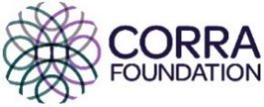
The Corra Foundation is a charity registered in Scotland (No SC009481) and is also a company limited by guarantee (No SC096068).

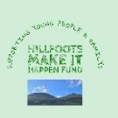 The Hillfoots Makes It Happen is a group of community members recruited from the Hillfoots area who have designed, developed and are the community voices that make decisions on the funding distributed by What Matters to You via The Corra Foundation.

