**What Matter to You and The Hillfoots Make It Happen Fund (HMIHF)**

**Application form**

Can you apply for the Hillfoots MIHF Check list

To progress an application, **you must be able to answer yes to all 7 questions.** If you are unable to do this, your organisation is **not** eligible to apply for the **Hillfoots Make It Happen Fund.**

**We have £10,000 available from this grants programme for funding of activities from January 2026. Applications are now open and will close on 10 October 2025. The grants are administered by Corra, who are supporting the ‘Hillfoots Make it Happen ’ to run the fund.**

* **The Hillfoots Make it Happen Fund is within the FK11 – FK14 Post code area which includes Alva , Tillicoultry, Pool of Muckhart, Dollar, Coalsnaughton ,Menstrie, Devonside**

**Please answer the following 7 questions**

1. Is your work based in and/or delivered in the Hillfoots area ?

Organisations based in other parts of Clackmannanshire can apply where there is voice from people of the Hillfoots fully included in the planning and delivery of the activity. The Hillfoots area is highlighted in yellow in the map below.

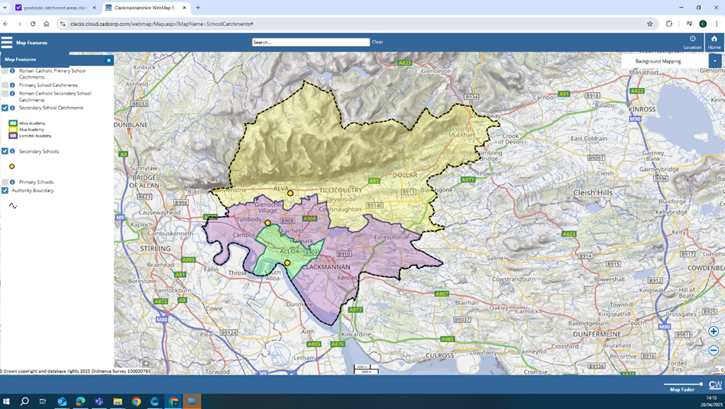

Yes/No

1. Does your group have an annual income of £50,000 or less?

**Yes/No**

1. Does your group provide services to benefit the people of the Hillfoots area in the following way ?

The Hillfoots Make it Happen is to benefit children, young people, families, parents, and carers. The Hillfoots Make it Happen Fund provides opportunities and improving lives for the benefit of children and families through :

* Building on Community Spirit, bringing community members together who want to make a change in their communities and sustain groups to benefit the Hillfoots community.
* Providing affordable, subsidised, or free opportunities and experiences.

**Yes/No**

1. Is your group not for profit?

This means all money raised or earned is spent on the costs of providing your current or future activities.

Yes/No

1. Is the activity you are applying for non-faith based?

This means that the activity you are applying for does not include promotion, teaching, or worship practice of any faith.

**Yes/No**

1. Is the activity you are applying for not politically affiliated?

This means that the activity you are applying for does not include the promotion practice of any political party.

Yes/No

1. Do you have at least 3 people on your committee/Board of Trustees/Directors/unconstituted group?

**Yes/No**

Please read the information and guidance before completing your application. If you would like advice or guidance with your application, please contact [jane@whatmatters2u.org.uk](mailto:jane@whatmatters2u.org.uk)

You can also download a copy of the application form at: <https://wm2u.co.uk/make-it-happen-fund>

**Application for the Hillfoots Make it Happen Fund**

1. **Project Title:**
2. **Name of group applying:**

(If you aren’t a formal group and have come together for this project idea the name of your group could just be the same as the project title)

**3.Description of your project:**

* What is your project or idea?
* When will it happen?
* Where will it happen ?
* What is the total cost ?

|  |
| --- |
| 250 words max : If you want to just bullet point that’s okay – just answer above questions. |

**4.How will your activity / project meet the aims of the fund?**

Promoting inclusion and improving the lives of children, young people, parents, families, carers of young people and young carers of the Hillfoots by:

* Building on Community Spirit, bringing community members together to make a change in their communities, and sustain groups to benefit the Hillfoots community.
* Providing affordable, subsidised, or free opportunities and experiences

|  |
| --- |
| 250 words max or use bullet points |

|  |  |
| --- | --- |
| 5. Which of the following best describes your group? | **Mark x** |
| We are an established group with a constitution |  |
| We are a registered charity or SCIO |  |
| We are a Community Interest Company (Asset-Locked) |  |
| We are an established group/project but don’t have a formal structure/constitution |  |
| We are a new group/project |  |
| Other (Please detail) |  |

**6.**Please tell us how you have involved the people of the Hillfoots in this application

( Community voice).

* How you have involved people of the Hillfoots
* Why you feel the need for this group, activity, event or initiative ?
* How will this benefit children, young people, parents, families , carers who live in the Hillfoots area.

|  |
| --- |
| 250 words max : If you want to just bullet point that’s okay – just answer above. |

7. Please tell us who will benefit from the project ?

* How many people do you hope that this will benefit ?

|  |
| --- |
|  |

8. Which of the following groups of people will the project benefit?

Please mark x at all of those that apply.

|  |  |
| --- | --- |
| Children (up to and including age 12) |  |
| Young People (aged 13 – 25) |  |
| Families |  |
| Young carers |  |
| Carers of young people and children. |  |

1. How much are you applying for from The Hillfoots Make it Happen Fund ?

|  |
| --- |
|  |

1. Please break down the Items that will be covered by the total cost of your project. For example travel, tickets, food, venue hire, sessional workers costs, materials, insurance. Then add the total cost to be paid for from the Make it Happen Fund.

|  |  |  |
| --- | --- | --- |
| **List of Costs** | **Cost £** | **Amount paid for by the Fund** |
|  |  |  |
|  |  |  |
|  |  |  |
|  |  |  |
|  |  |  |
|  |  |  |
|  |  |  |
|  |  |  |
|  |  |  |
|  |  |  |
| **Total** |  |  |

1. Tell us about any relevant experience that the group of people who are applying have to deliver the project. Or young people who are applying , tell us how you are supported by a larger group or organisation ?

|  |
| --- |
| Max 250 words. You can bullet point |

|  |  |
| --- | --- |
| 12. How many people from your community are involved in your group? | Insert Number |
| Organising Committee members or Trustees |  |
| Other Volunteers |  |

1. How will you keep people safe? We are committed to ensuring that all funded projects create safe, inclusive, and respectful environments for participants, staff, and volunteers. Tell us if you have a safeguarding policy and what checks you do on volunteers.

By safeguarding we mean the action taken to promote the welfare of children and vulnerable adults to

protect them from harm, including physical, emotional, sexual and financial harm and neglect.

If you do not have a safeguarding policy and appropriate checks for staff and volunteers, this needs to be in place before the activity starts. Here are some useful resources. [https://scvo.scot/support/running-your-organisation/safeguarding](https://eur03.safelinks.protection.outlook.com/?url=https%3A%2F%2Fscvo.scot%2Fsupport%2Frunning-your-organisation%2Fsafeguarding&data=05%7C02%7Cjane%40whatmatters2u.org.uk%7C0cb8d4b4efe5461fb59908dde08b818a%7C73c4cbfeaa824c558d05196185602593%7C1%7C0%7C638913611984227943%7CUnknown%7CTWFpbGZsb3d8eyJFbXB0eU1hcGkiOnRydWUsIlYiOiIwLjAuMDAwMCIsIlAiOiJXaW4zMiIsIkFOIjoiTWFpbCIsIldUIjoyfQ%3D%3D%7C0%7C%7C%7C&sdata=Yw4OiG5VXvcUtvKPJgktJB%2B46nrTSCqAo1D7x%2B%2F%2B1EY%3D&reserved=0); [https://www.volunteerscotland.net/disclosure-services](https://eur03.safelinks.protection.outlook.com/?url=https%3A%2F%2Fwww.volunteerscotland.net%2Fdisclosure-services&data=05%7C02%7Cjane%40whatmatters2u.org.uk%7C0cb8d4b4efe5461fb59908dde08b818a%7C73c4cbfeaa824c558d05196185602593%7C1%7C0%7C638913611984544099%7CUnknown%7CTWFpbGZsb3d8eyJFbXB0eU1hcGkiOnRydWUsIlYiOiIwLjAuMDAwMCIsIlAiOiJXaW4zMiIsIkFOIjoiTWFpbCIsIldUIjoyfQ%3D%3D%7C0%7C%7C%7C&sdata=aULc5eb%2BxzpLp3WaNM0IZX%2BSSrHPMCO86blBv1BhIHI%3D&reserved=0); <https://ctsi.org.uk/>

|  |
| --- |
| Tell us do you have safeguarding policies and appropriate checks for staff and volunteers. |

14. What are the usual annual running costs of your group? Running costs would include the things you need to run your group such as refreshments, hall hire, insurance, transport, volunteers expenses, materials, sessional workers. If you are a new group, please estimate what these would be.

|  |  |
| --- | --- |
| Annual running cost | Mark x |
| 0 to £1000 |  |
| £1000 to £5, 000 |  |
| £5,000 to £20,000 |  |
| £20,000 to £50,000 |  |

1. Do you have a bank account in the organisation’s group’s name?
2. How much do you have in this account?

17. If you do not have a bank account, we can pay your award into another organisation’s bank account, “your buddy account”. Tell us yes or no if you will need this.

**YES NO**

**18. Main Contact details for application/project** (name, address, phone and email): **(we must have an email address to be able to correspond with you)**

|  |
| --- |
|  |

By completing my name and email address in this form I agree to What Matters to You, The Hillfoots Make It Happen Fund and Corra Foundation contacting me by email and phone regarding my application and any subsequent grant.

**What Matters to You**, and **The Hillfoots Make it Happen Fund** will use this data to:

* Assess your application for a grant.
* Arrange visits by **The Hillfoots Make it Happen Fund**  and What Matters to You to your project during the term of your grant.
* Inform you, with your consent, about grant opportunities, training events, relevant seminars, community events and conferences that may be of interest to you and to consult with you through surveys.

**Corra Foundation** will use this data to:

* Monitor any grant made to your organisation and to perform any other requirements set out in the grant agreement between us.
* Allow us to perform our part of the grant agreement and to allow us to report to any other organisation involved in the funding of the grant, and our funders, where applicable.
* Inform you, with your consent, about grant opportunities, training events and relevant seminars and conferences that may be of interest to you and to consult with you through surveys.

**What Matters to You**, **The Hillfoots Make it Happen Fund** and **Corra Foundation** may also use personal data that identifies you, such as photographs, in reports to our funders.

**What Matters to You**, **The Hillfoots Make it Happen Fund** and **Corra Foundation** will retain your personal data for one year following the date What Matters to You receives your application, or three years after the review date of the final grant payment, whichever is later. This will be deleted thereafter, unless you consent for us to retain it.

If you want to find out more about what Corra Foundation and What Matters to You do with your data, you can access their Privacy Notices:

<https://www.corra.scot/privacy-notice/>

<https://wm2u.co.uk/privacy>

If you would like **Corra Foundation** or **What Matters to You** to let you know about future grant opportunities, training events, relevant seminars and conferences that may be of interest to you, and to consult with you through surveys please give your consent here:

**Corra Foundation communications**

|  |  |
| --- | --- |
|  | I would like to receive this information |
|  |  |
|  | I do NOT want to receive this information |

If you wish to withdraw your consent in relation to this information, you can do so at any time by contacting Corra Foundation on 0131 444 4020 or by email [mihf@corra.scot](mailto:mihf@corra.scot)

**What Matters to You communications**

|  |  |
| --- | --- |
|  | I would like to receive this information |
|  |  |
|  | I do NOT want to receive this information |

If you wish to withdraw your consent in relation to this information, you can do so at any time by contacting What Matters to You by email [jane@whatmatters2u.org.uk](mailto:jane@whatmatters2u.org.uk)

Please note that if you withdraw consent to receiving communications this does not affect the retention of your data, as stated again in the paragraph below.

**What Matters to You**, **The Hillfoots MIHF** and **Corra Foundation** will retain your personal data for one year following the date What Matters to You receives your application, or three years after the review date of the final grant payment, whichever is later. This will be deleted thereafter, unless you consent for us to retain it.

|  |
| --- |
| **16. Acknowledgement: Please read the statement, sign to acknowledge and date** |
| *I have read and understood the information and guidance and to the best of my knowledge the information in this application is correct.*  *I confirm that I am authorised to sign this on behalf of my organisation.*  *I confirm the proposed project will directly benefit the communities of the Hillfoots in Clackmannanshire.*  *I confirm that Corra Foundation can publish the name and objectives of my organisation and the details of financial support given, including as part of media releases or publications.*  *I agree to What Matters to You, The Hillfoots Make it Happen Fund**and the Corra Foundation contacting me by email.*  ***Applicant Signature:***  ***Print Name: Date:*** |

**Completed Applications should be returned no later than Friday 10th October at 5 p.m.** Applications should be emailed to [jane@whatmatters2u.org.uk](mailto:jane@whatmatters2u.org.uk) or addressed to What Matters to You, The Hillfoots Make It Happen Fund and returned to *one* of the following locations in a sealed envelope:

* Cochrane Hall, The Cochrane Hall Park, Alva, FK125LJ
* Coalsnaughton, Devonside and Langour Village Hall, 30 Main Street, Coalsnaughton, Clackmannanshire, FK136JH

**Grant Allocation Process:** Applications which best fit the fund will be invited to a celebration event on Friday 21st Nov 6 p.m. – 8 p.m. at The Cochrane Hall, Alva. to meet with the ‘**The Hillfoots Make it Happen Fund’** volunteer community panel and other potential beneficiaries of the grant.

There may be conditions as a part of the grant offer, including safeguarding training, and these will be clearly outlined as part of the grant offer letter.

Please read the full guidance notes before sending completed applications.

What Matters to You is supported through a partnership between The Hunter Foundation and BBC Children In Need. The Make It Happen Fund is part of the What Matters to You approach with funding from BBC Children in Need, The Hunter Foundation, The Robertson Trust and William Grant Foundation. Corra Foundation is administering the grant on behalf of What Matters to You.

**The Corra Foundation** is a charity registered in Scotland (No SC009481) and is also a company limited by guarantee (No SC096068). Office Suite 30, Pure Offices, 4 Lochside Way, Edinburgh, EH12 9DT.

**The Hillfoots Makes It Happen** is a group of volunteer community members recruited from The Hillfoots area who have designed, developed and are the community voices that make decisions on the funding distributed by What Matters to You via The Corra Foundation

.