**WM2U, Make It Happen Fund –Grassroots MIHF**

**Information and Guidance for Applying**

**You can download a copy of the application form at:**

<https://wm2u.co.uk/make-it-happen-fund>

**1. Overview**

**The Grassroots Make It Happen Fund (MIHF)**

The Grassroots Make It Happen Fund is run by local people for local people. The aim is to support and encourage local groups, by offering funding to them to support projects and initiatives that create positive change within their communities.

**The Grassroots Make It Happen Fund is for the catchment areas of Lornshill and Alloa highlighted in pink and green.**

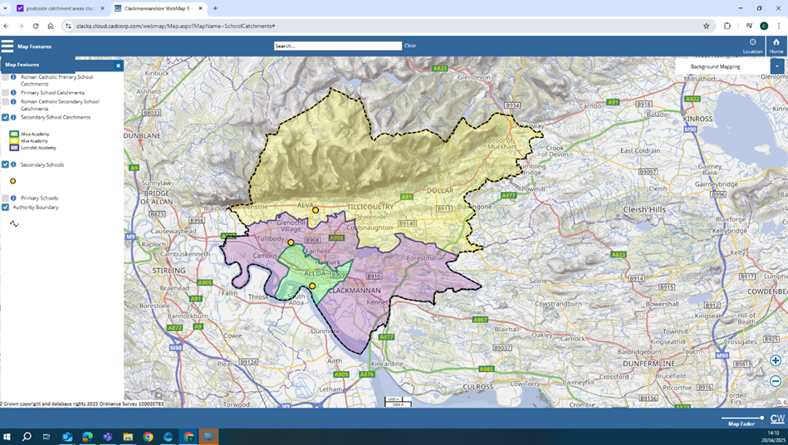

The money comes from The Grassroots What Matters to You Make It Happen Fund in the **area of Lornshill and Alloa.**

**The Grassroots Make It Happen Fund** has £20,000 available from the grants programme. The grants are administered by Corra, who are supporting **The Grassroots Make It Happen Fund** to run the fund.

**The** **Grassroots Make It Happen Fund** is made up of local people recruited by **What Matters to You** from the catchment areas of Alloa and Lornshill academies who have come together to encourage community engagement that will benefit the people of the area.

**The Grassroots Make It Happen Fund** will make decisions together on all applications with £10,000 being available for the catchment area of Alloa and £10,000 for the Lornshill area.

**2.** **Drop-In Information Sessions**

You are encouraged to come for more information, and guidance to fill out the form at a drop-in information session on either:

* **Thursday 18th September** 6 p.m. – 8 p.m. The Hive, 21 Mill St, Alloa
* **Friday 19th September** 10 a.m. – 12 noon The Hive, 21 Mill St, Alloa
* **Monday 22nd September** 1.30 p.m. – 3 p.m. at Sauchie Resource Centre 11, Mars Pl, Sauchie, Alloa FK10 3EA
* **Wednesday 24th September** 12.30 p.m. – 2 p.m. Tullibody Library, South Campus, The Orchard, Tullibody, Alloa, FK102SD.

**Thursday 25th September** 10 a.m. – 12 noon The Bruce Lounge, 1 Main St, Clackmannan

* **Thursday 25th September** 6.30 p.m. – 7.30 p.m. in Sauchie Hall, Mars Pl, Alloa.

You can collect a copy of the application form at the drop-in, or download from <https://wm2u.co.uk/make-it-happen-fund>



**3. Aims of the fund**

* To improve and support the ambitions of the community.
* To improve wellbeing of children, young people, families, parents and their carers.
* To put the feel-good factor back into our communities.



**4. Who can apply?**

**The Grassroots Make It Happen** is to benefit children, young people, families, parents, and carers of children and young people. This also includes young people who may have a carer responsibility for a family member.

**The Grassroots Make It Happen Fund** is open to not-for-profit organisations based in the catchment areas, both constituted and non-constituted, whose services are being delivered in and benefit the area.

Organisations based in other parts of Clackmannanshire can apply to run activities in the catchment areas of Alloa and Lornshill, provided children, young people and families from the area have been included in the planning and delivery of the activity.

Applicant organisations/groups should have an **annual income of less than £25,000**

(as noted in their most recent approved accounts, we don’t expect un - constituted groups to have accounts).

Groups must be **not** for profit. This means all money raised or earned is spent on the costs of providing current or future activities. The group/organisation can be formally constituted, **or** an informal unconstituted group with at least 3 people involved. A social enterprise or Community Interest Company must have at least 3 Directors none of which has significant control and should also have an asset lock.

Groups of young people that are supported by a larger organisation with an income over £25,000 but where the group has a degree of independence. For example, where the group of young people makes decisions on what to do and is instrumental in the running of those activities with some support. The supporting organisation cannot be a public service or statutory organisation such as a school or local authority youth or community development project. The young people could apply if the supporting organisation is a charity or a constituted group of interested parents, volunteers or a parent council.

**5. What can be funded?**

The grant can be used for costs of a specific project or activity, running **from January 2026**, that helps the group/organisation to achieve the outcomes of the fund.

**Types of activity:**

* Time limited activities
* One off event (but not the established Gala days)
* Day trips
* To continue existing activities
* To start new activities

**Types of costs**

* Materials to deliver activities.
* Catering or food costs associated with activities.
* Equipment
* Travel costs to support with delivery of activities.
* Reasonable travel expenses for supporting volunteers.
* Sessional delivery from external tutors or organisations
* Hall / venue hire.
* Start-up costs of new organisations e.g. insurance

**6. How much can be applied for?**

Up to £500 per application.

You can only make one application for your organisation.

The Grant can be used for full project funding or part project funding where there is evidence of that match funding has been secured at the time of application.

**7.What CANNOT be funded?**

* Major items such as building projects, motor vehicles and refurbishment costs.
* General regular running costs of existing organisations, such as rent, utilities or office costs
* Costs associated with gambling type activities.
* Alcohol in the provision of refreshments
* Gala days
* Overseas trips
* Food Parcels
* Cash or vouchers for example for food, clothes or household bills
* Salary or staffing costs of the applicant, including paying the Director of a Community Interest Company to run an activity.
* Activities that have already happened or things already bought.
* Activities that are for the promotion, teaching, or worship practice of any faith.
* Activities that are for the promotion of anything political.
* Mainstream activities and statutory services of public bodies such as hospitals and medical centres, schools, universities, and colleges.

Some examples:

A local authority nursery cannot apply. A group of parents from the nursery who wish to run an activity themselves, can apply. Similarly, Parent Councils of schools can apply to run activities themselves

A Community Interest Company (CIC) cannot apply to pay its Directors to run an activity. If another organisation (which meets the criteria), wishes to engage the CIC to provide an activity for their organisation, then that organisation can apply for the costs of engaging the CIC.

An existing organisation cannot apply for its regular core running costs such as office rent, utilities or salaries. It can apply for the costs of a new or existing project.

A group cannot apply to give cash or vouchers to participants. But it can apply for the costs of providing equipment or uniforms for participants.

A football club which has multiple teams and each team runs itself but under the constitution of the club, can only apply once, providing it fits the income criteria. The individual teams cannot apply.

An existing organisation cannot apply for its regular core running costs such as office rent, utilities or salaries. It can apply for the costs of a new or existing activity or project. This might include venue hire, equipment, insurance. For example, an organisation runs several projects in the area. It has a small office with a part-time staff member. The activities are run elsewhere. The organisation cannot apply for the office costs or staff member. It can apply for costs of running the projects, such as venue hire, external tutors, materials.

**8. Writing your application**

Thinking about your project:

* How does the project benefit children, young people, families, parents, and carers.

**9. Where and when to send your application**

**Completed Applications should be returned no later than Friday 10th October at 5 p.m.**

Applications should be emailed to [jane@whatmatters2u.org.uk](mailto:jane@whatmatters2u.org.uk) or

returned by hand to The Hive, 21 Mill Street, Alloa in a sealed envelope.

Envelopes should be addressed to FAO Jane Carter, What Matters to You,

The Grassroots Make It Happen Fund.

**10. How will decisions be made?**

The Grassroots Makes It Happen group will

* consider which applications best fit the guidelines
* send a decision letter to every applicant
* give feedback to those that are not successful
* invite those who have been awarded a grant to attend or send representation to a celebration event on 29th November 2025 at The Hive Alloa 2 – 4 p.m.

**11. Grant Conditions**

* Allocated funds must be spent within one year of receipt. Funds cannot be spent before a grant is allocated and can only be spent as outlined in the grant application.
* If you do not have a safeguarding policy and appropriate checks for staff and volunteers, this needs to be in place before the activity starts. Here are some useful resources. [https://scvo.scot/support/running-your-organisation/safeguarding](https://eur03.safelinks.protection.outlook.com/?url=https%3A%2F%2Fscvo.scot%2Fsupport%2Frunning-your-organisation%2Fsafeguarding&data=05%7C02%7Cjane%40whatmatters2u.org.uk%7C0cb8d4b4efe5461fb59908dde08b818a%7C73c4cbfeaa824c558d05196185602593%7C1%7C0%7C638913611984227943%7CUnknown%7CTWFpbGZsb3d8eyJFbXB0eU1hcGkiOnRydWUsIlYiOiIwLjAuMDAwMCIsIlAiOiJXaW4zMiIsIkFOIjoiTWFpbCIsIldUIjoyfQ%3D%3D%7C0%7C%7C%7C&sdata=Yw4OiG5VXvcUtvKPJgktJB%2B46nrTSCqAo1D7x%2B%2F%2B1EY%3D&reserved=0); [https://www.volunteerscotland.net/disclosure-services](https://eur03.safelinks.protection.outlook.com/?url=https%3A%2F%2Fwww.volunteerscotland.net%2Fdisclosure-services&data=05%7C02%7Cjane%40whatmatters2u.org.uk%7C0cb8d4b4efe5461fb59908dde08b818a%7C73c4cbfeaa824c558d05196185602593%7C1%7C0%7C638913611984544099%7CUnknown%7CTWFpbGZsb3d8eyJFbXB0eU1hcGkiOnRydWUsIlYiOiIwLjAuMDAwMCIsIlAiOiJXaW4zMiIsIkFOIjoiTWFpbCIsIldUIjoyfQ%3D%3D%7C0%7C%7C%7C&sdata=aULc5eb%2BxzpLp3WaNM0IZX%2BSSrHPMCO86blBv1BhIHI%3D&reserved=0); <https://ctsi.org.uk/>
* Instructions/conditions for claiming awarded grants will be sent with award letters along with any other conditions*.*

**12. How will the money be paid?**

* Corra Foundation are handling the administration and payment of the grant.
* The grant will be paid in one instalment into the bank or credit union account of the group.
* If the group does not have a bank account, we can pay the grant into the account of another group (Buddy Group) which agrees to hold the money for you.
* After the celebration event, Corra will send the successful applicants a Grant Offer letter. This should be signed and returned along with bank details and a bank statement. It takes around 10 days from when Corra receives the completed paperwork, to the money being paid into a bank account.

**13. What happens after?**

We want to hear how you’re getting on with your project.

* We plan to visit projects to find out how things are going.
* We ask that you collect photos, video, art and stories from the community participants and your own learning, to show the activity and the difference it made to people.

**You can collect a copy of the application form at the drop-in, or download from** <https://wm2u.co.uk/make-it-happen-fund>

What Matters to You is supported through a partnership between The Hunter Foundation and BBC Children in Need. The Make It Happen Fund is part of the What Matters to You approach with funding from BBC Children in Need, The Hunter Foundation, The Robertson Trust and William Grant Foundation

The Corra Foundation is a charity registered in Scotland (No SC009481) and is also a company limited by guarantee (No SC096068).

**The Grassroots Makes It Happen** is a group of community members recruited from the Alloa and Lornshill catchment area who have designed, *developed and are the community* voices that make decisions on the funding distributed by What Matters to You via The Corra Foundation.