**What Matter to You and The Grassroots Make It Happen Fund (GMIHF)**

**Application form**

Can you apply for The Grassroots Make it Happen Fund ?

* Application forms can be completed electronically or hand written – your choice.
* To progress an application, **you must be able to answer yes to all 7 questions.** If you are unable to do this, your organisation is **not** eligible to apply for **The Grassroots Make It Happen Fund**
* **The Grassroots Make It Happen Fund is for the catchment areas of Lornshill and Alloa academies.**

**Your Check list** **Please answer the following 7 questions**

1. Is your work based in and/or delivered in the Alloa and Lornshill catchment area ?

Organisations based in other parts of Clackmannanshire can apply where the people who live in the area’s highlighted below in pink and yellow have been fully included in the planning and delivery of the activity. But the activity needs to be delivered in these areas.

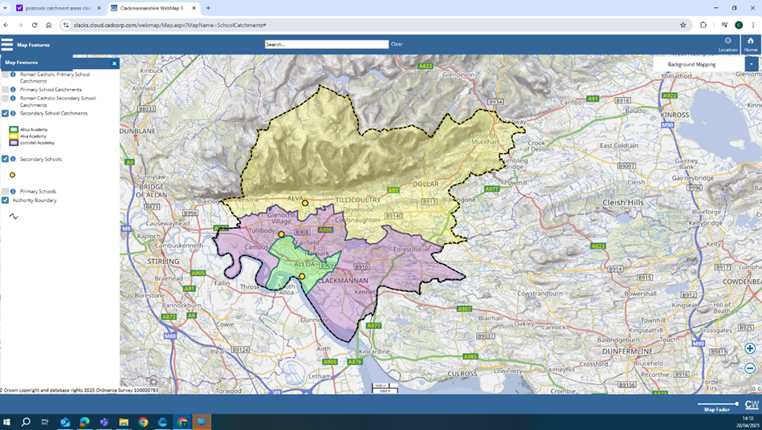

**Yes / No**

1. Does your group have an annual income of £25,000 or less?

**Yes/No**

1. Does your group provide services to benefit the people in the following way ? :

The Grassroots Make it Happen is to benefit children, young people, families, parents, and carers.

* To improve wellbeing of children, young people, families, parents and their carers’.
* To improve and support the ambitions of the community
* To put the feel good factor back into your communities.

**Yes/No**

1. Is your group non - profit?

This means all money raised or earned is spent on the costs of providing your current or future activities.

**Yes/No**

1. Is the activity you are applying for non-faith based?

This means that the activity you are applying for does not include promotion, teaching, or worship practice of any faith.

**Yes/No**

1. Is the activity you are applying for not politically affiliated?

This means that the activity you are applying for does not include the promotion practice of any political party.

**Yes/No**

1. Do you have at least 3 people on your committee/Board of Trustees/Directors?

Or, if you are a constituted group do you have 3 or more people in your group ?

*( A constituted group is an informal group that has a written list of rules and guidelines to help make it clear to everyone involved what you intend to do and how you intend to operate).*

Or, if you are an unconstituted group do you have 3 or more people in your group ?

*( An unconstituted group are groups of individuals who come together to undertake a particular activity or shared interest ).*

**Yes/No**

**Please read the information and guidance before completing and sending your application. If you have a question or want to talk through your project, please contact**

[**jane@whatmatters2u.org.uk**](mailto:jane@whatmatters2u.org.uk)

**There will be community drop in sessions where you can ask further questions and get guidance to fill in your application form and meet the volunteer community members of The Grassroots Make it Happen Fund Panel at the following locations on ;**

* **Thursday 18th September** 6 p.m. – 8 p.m. **The Hive**, 21 Mill St, Alloa
* **Friday 19th September** 10 a.m. – 12 noon **The Hive,** 21 Mill St, Alloa
* **Monday 22nd September** 1.30 p.m. – 3 p.m. at **Sauchie Resource Centre** 11, Mars Pl, Sauchie, Alloa FK10 3EA
* **Wednesday 24th September** 12.30 p.m. – 2 p.m. at **Tullibody Library**, South Campus, The Orchard, Tullibody, Alloa, FK102SD.
* **Thursday 25th September** 10 a.m. – 12 noon, **The Bruce Lounge**, 1 Main St, Clackmannan.
* **Thursday 25th September** 6.30 p.m. – 7.30 p.m. in **Sauchie Hall**, Mars Pl, Alloa

**You can also download a copy of the application form at:** <https://wm2u.co.uk/make-it-happen-fund>

**Application for The Grassroots Make it Happen Fund**

1. **Project Title:**
2. **Name of group applying:**

(If you aren’t a formal group and have come together for this project idea the name of your group could just be the same as the project title)

1. **Description of your project:**
2. **What is your project or idea?**
3. **Who is the project for and how many will take part?**
4. **When and Where will it happen ?**

|  |
| --- |
| 1. **How will it meet the aims of the fund by? :**  * Improving and supporting the ambitions of the community * Improving the wellbeing of children, young people, families, parents and their carer’s. * Putting the feel good factor back into our communities.   250 words max : If you want to just bullet point that’s okay |

|  |
| --- |
| 1. **Why you think this group, activity, event or project is needed?**   200 words max : If you want to just bullet point that’s okay |

|  |
| --- |
|  |

**6. Which of the following groups of people will the project benefit?**

**Please mark x at all of those that apply.**

|  |  |
| --- | --- |
| Children (up to and including age 12) |  |
| Young People (aged 13 – 25) |  |
| Families |  |
| Young carers |  |
| Carers of young people and children. Kinship care |  |

|  |  |
| --- | --- |
| **7. Which of the following best describes your group ?** | **Mark x** |
| We are an established group with a constitution |  |
| We are a registered charity or SCIO |  |
| We are a Community Interest Company |  |
| We are an established group/project but don’t have a formal structure/constitution |  |
| We are a new group/project |  |
| Other (Please detail) |  |

**8. a. What is the total cost of your project / activity ?**

**b. And how much are you applying for from this fund ?**

1. **a. If your project costs more than £500, have you secured match funding ? Yes or No**
2. **If yes, where have you secured the match funding from and how much?**

**10. Please give some more detail about what the Grassroots Make It Happen Fund grant would pay for?**

**List the items and cost, such as travel, tickets, food, venue hire, sessional workers costs, equipment, materials, insurance.**

|  |  |
| --- | --- |
| **Description** | **Cost** |
|  |  |
|  |  |
|  |  |
|  |  |
|  |  |
|  |  |
|  |  |
|  |  |
| **Total** |  |

|  |
| --- |
| 1. **Tell us about any relevant experience that the group of people who are applying have to deliver the project.**   **If you are a group of young people to apply to run an activity yourselves, tell us who is supporting you and how?**  Max 250 words. You can bullet point |

|  |  |
| --- | --- |
| **12. How many people from your community are involved in your group?** | **Insert Number** |
| Organising Committee members or Trustees |  |
| Other Volunteers |  |

1. How will you keep people safe? We are committed to ensuring that all funded projects create safe, inclusive, and respectful environments for participants, staff, and volunteers. Tell us if you have a safeguarding policy and what checks you do on volunteers.

By safeguarding we mean the action taken to promote the welfare of children and vulnerable adults to

protect them from harm, including physical, emotional, sexual and financial harm and neglect.

If you do not have a safeguarding policy and appropriate checks for staff and volunteers, this needs to be in place before the activity starts. Here are some useful resources. [https://scvo.scot/support/running-your-organisation/safeguarding](https://eur03.safelinks.protection.outlook.com/?url=https%3A%2F%2Fscvo.scot%2Fsupport%2Frunning-your-organisation%2Fsafeguarding&data=05%7C02%7Cjane%40whatmatters2u.org.uk%7C0cb8d4b4efe5461fb59908dde08b818a%7C73c4cbfeaa824c558d05196185602593%7C1%7C0%7C638913611984227943%7CUnknown%7CTWFpbGZsb3d8eyJFbXB0eU1hcGkiOnRydWUsIlYiOiIwLjAuMDAwMCIsIlAiOiJXaW4zMiIsIkFOIjoiTWFpbCIsIldUIjoyfQ%3D%3D%7C0%7C%7C%7C&sdata=Yw4OiG5VXvcUtvKPJgktJB%2B46nrTSCqAo1D7x%2B%2F%2B1EY%3D&reserved=0); [https://www.volunteerscotland.net/disclosure-services](https://eur03.safelinks.protection.outlook.com/?url=https%3A%2F%2Fwww.volunteerscotland.net%2Fdisclosure-services&data=05%7C02%7Cjane%40whatmatters2u.org.uk%7C0cb8d4b4efe5461fb59908dde08b818a%7C73c4cbfeaa824c558d05196185602593%7C1%7C0%7C638913611984544099%7CUnknown%7CTWFpbGZsb3d8eyJFbXB0eU1hcGkiOnRydWUsIlYiOiIwLjAuMDAwMCIsIlAiOiJXaW4zMiIsIkFOIjoiTWFpbCIsIldUIjoyfQ%3D%3D%7C0%7C%7C%7C&sdata=aULc5eb%2BxzpLp3WaNM0IZX%2BSSrHPMCO86blBv1BhIHI%3D&reserved=0); <https://ctsi.org.uk/>

|  |
| --- |
| Tell us do you have safeguarding policies and appropriate checks for staff and volunteers. |

**14. What are the usual annual running costs of your group?** Running costs would include the things you need to run your group such as refreshments, hall hire, insurance, transport, volunteers expenses, materials, sessional workers. If you are a new group, please estimate what these would be.

|  |  |
| --- | --- |
| **Annual running cost** | **Mark x** |
| **0 to £1,000** |  |
| **£1,000 to £5, 000** |  |
| **£5,000 to £10,000** |  |
| **£10,000 to £15,000** |  |
| **£15,000 to £20,000** |  |
| **£20,000 to £25,000** |  |

**15.a. Do you have a bank account in the organisations / group name?**

**b. How much is currently in the bank account ?**

1. **Is any of this money been given for a specific purpose and can’t be used for your project ?**

**16. Main Contact details for application/project** (name, address, phone and email): **(we must have an email address to be able to correspond with you)**

|  |
| --- |
|  |

By completing my name and email address in this form I agree to What Matters to You, The Grassroots Make It Happen Fund and Corra Foundation contacting me by email and phone regarding my application and any subsequent grant.

**What Matters to You**, and **The Grassroots MIHF** will use this data to:

* Assess your application for a grant.
* Arrange visits by The Grassroots MIHF and What Matters to You to your project during the term of your grant.
* Inform you, with your consent, about grant opportunities, training events, relevant seminars, community events and conferences that may be of interest to you and to consult with you through surveys.

**Corra Foundation** will use this data to:

* Monitor any grant made to your organisation and to perform any other requirements set out in the grant agreement between us.
* Allow us to perform our part of the grant agreement and to allow us to report to any other organisation involved in the funding of the grant, and our funders, where applicable.
* Inform you, with your consent, about grant opportunities, training events and relevant seminars and conferences that may be of interest to you and to consult with you through surveys.

**What Matters to You**, **The Grassroots MIHF** and **Corra Foundation** may also use personal data that identifies you, such as photographs, in reports to our funders.

**What Matters to You**, **The Grassroots MIHF** and **Corra Foundation** will retain your personal data for one year following the date What Matters to You receives your application, or three years after the review date of the final grant payment, whichever is later. This will be deleted thereafter, unless you consent for us to retain it.

If you want to find out more about what Corra Foundation and What Matters to You do with your data, you can access their Privacy Notices:

<https://www.corra.scot/privacy-notice/>

<https://wm2u.co.uk/privacy>

If you would like **Corra Foundation** or **What Matters to You** to let you know about future grant opportunities, training events, relevant seminars and conferences that may be of interest to you, and to consult with you through surveys please give your consent here:

**Corra Foundation communications**

|  |  |
| --- | --- |
|  | I would like to receive this information |
|  |  |
|  | I do NOT want to receive this information |

If you wish to withdraw your consent in relation to this information, you can do so at any time by contacting Corra Foundation on 0131 444 4020 or by email [mihf@corra.scot](mailto:mihf@corra.scot)

**What Matters to You communications**

|  |  |
| --- | --- |
|  | I would like to receive this information |
|  |  |
|  | I do NOT want to receive this information |

If you wish to withdraw your consent in relation to this information, you can do so at any time by contacting What Matters to You by email [jane@whatmatters2u.org.uk](mailto:jane@whatmatters2u.org.uk)

Please note that if you withdraw consent to receiving communications this does not affect the retention of your data, as stated again in the paragraph below.

**What Matters to You**, **The Grassroots MIHF** and **Corra Foundation** will retain your personal data for one year following the date What Matters to You receives your application, or three years after the review date of the final grant payment, whichever is later. This will be deleted thereafter, unless you consent for us to retain it.

|  |
| --- |
| **16. Acknowledgement: Please read the statement, sign to acknowledge and date** |
| *I have read and understood the information and guidance and to the best of my knowledge the information in this application is correct.*  *I confirm that I am authorised to sign this on behalf of my organisation.*  *I confirm the proposed project will directly benefit the communities of the Grassroots Make It Happen Fund in Clackmannanshire.*  *I confirm that Corra Foundation can publish the name and objectives of my organisation and the details of financial support given, including as part of media releases or publications.*  *I agree to What Matters to You, The Grassroots MIHF and the Corra Foundation contacting me by email.*  ***Applicant Signature:***  ***Print Name: Date:*** |

**Completed Applications should be returned no later than Friday 10th October at 5 p.m. Applications should be emailed to** [**jane@whatmatters2u.org.uk**](mailto:jane@whatmatters2u.org.uk)

**or addressed to Jane Carter at What Matters to You Grassroots Make It Happen Fund and returned to The Hive, 21 Mill St, Alloa in a sealed envelope.**

Grant Allocation Process: Applications which best fit the fund will be invited to a celebration event to meet with the ‘Grassroots MIHF volunteer community panel and other potential beneficiaries of the grants at The Hive, Alloa on Saturday 29th November 2025 2 – 4 p.m.

There may be conditions as a part of the grant offer, including safeguarding training, and these will be clearly outlined in the grant offer letter.

What Matters to You is supported through a partnership between The Hunter Foundation and BBC Children In Need. The Make It Happen Fund is part of the What Matters to You approach with funding from BBC Children in Need, The Hunter Foundation, The Robertson Trust and William Grant Foundation. Corra Foundation is administering the grant on behalf of What Matters to You.

**The Corra Foundation** is a charity registered in Scotland (No SC009481) and is also a company limited by guarantee (No SC096068). Office Suite 30, Pure Offices, 4 Lochside Way, Edinburgh, EH12 9DT.

**The Grassroots Make It Happen** is a group of volunteer community members recruited from The Alloa and Lornshill catchment area who have designed, developed and are the community voices that make decisions on the funding distributed by What Matters to You via The Corra Foundation.