
WM2U Make It Happen Fund – East End (Douglas, Craigie, Mid-Craigie & Linlathen Application form

Eligibility Checker
To progress an application, you must be able to answer yes to all questions. If you are unable to do this, your organisation is not eligible to apply for the East End Ward Make It Happen Fund.
Is your work based in and/or delivered in the East End Ward? Organisations based in other parts of Dundee can apply where there is voice from people of East End fully included in the planning and delivery of the activity.
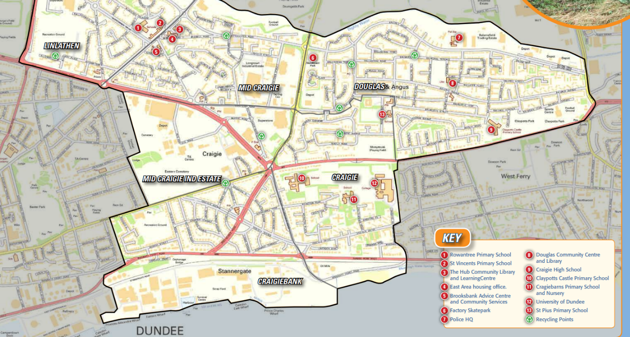
Yes/No
Does your group have an annual income of £20,000 or less?
Yes/No
Does your group provide services to benefit the people of East End through:
• Improving life for families across the ward
• Creating and delivering affordable opportunities
• Providing equality of opportunity for all families living in the East End ward

Yes/No
Is your group not for profit? This means all money raised or earned is spent on the costs of providing your current or future activities.
Yes/No
Is the activity you are applying for non-faith based? This means that the activity you are applying for does not include promotion, teaching, or worship practice of any faith.
Yes/No
Is the activity you are applying for not politically affiliated? This means that the activity you are applying for does not include the promotion practice of any political party.
Yes/No
Do you have at least 3 people on your committee/Board of Trustees/Directors/unconstituted group?
Yes/No

Please read the information and guidance before completing your application. If you would like help with your application or want to talk through your project, please contact Hayley Tunstall hayley.tunstall@dundeecity.gov.uk

You can download a copy of the application form at:
https://wm2u.co.uk/East End-make-it-happen-fund

1. Project Title:

2. Name of group applying:
(If you aren’t a formal group and have come together for this project idea the name of your group could just be the same as the project title)

3.Description of your project: What is your project or idea? When will it happen? How will it meet the aims of the fund by:
- Improving life for families across the ward
- Creating and delivering affordable opportunities
- Providing equality of opportunity for all families living in the East End ward

4. Please tell us how people from East End have been involved in developing and designing your ideas in this application?

5. Please tell us who will benefit from the project and how many. For some projects this may be a large number and for others relatively small depending on the type of activity being undertaken.

5. Which of the following groups of people will the project benefit? Please mark x at all of those that apply.

Children (up to and including age 12)
Young People (aged 13 – 25)
Families
Adult Groups

6. What is the difference that your project will make for the people of East End? For example, how the activities will help people? Greater sense of community, reduced isolation, etc.

7. What is the total cost of your project/idea?

8. Do you have any other funds to contribute towards this project/idea and if so, where are they coming from and are they already secured or under application?

9. How much are you applying for from the East End Make It Happen Fund?

10. Please give some more detail about the costs and what the East End Make It Happen Fund grant would pay for? List the items and cost, such as travel, tickets, food, venue hire, sessional workers costs, materials, insurance.

Description | Cost
Total

11. Which of the following best describes your group? | Mark x
We are an established group with a constitution
We are a registered charity or SC
IO
We are a Community Interest Company
We are an established group/project but don’t have a formal structure/constitution
We are a new group/project
Other (Please detail)

12. Tell us about any relevant experience that the group of people who are applying have to deliver the project.

13. How many people from your community are involved in your group? | Insert Number
Organising Committee members or Trustees
Other Volunteers

14. How will you keep people safe? Tell us if you have a safeguarding policy. If you do not have a safeguarding policy support and training will be provided. By safeguarding we mean the action taken to promote the welfare of children and vulnerable adults to protect them from harm, including physical, emotional, sexual and financial harm and neglect.

15. What are the usual annual running costs of your group? Running costs would include the things you need to run your group such as refreshments, hall hire, insurance, transport, volunteers expenses, materials, sessional workers. If you are a new group, please estimate what these would be.

Annual running cost | Mark x
Up to £1000
£1000 to £5000
£5,000 to £20000

16. Do you have an active bank account?

Active Bank Account | Mark x
Yes
No

17. What is the current balance in your bank account?

18. Main Contact details for application/project (name, address, phone and email): (we must have an email address to be able to correspond with you)

By completing my name and email address in this form I agree to What Matters to You, The East End Make It Happen Fund and Corra Foundation contacting me by email and phone regarding my application and any subsequent grant.
What Matters to You, and The East End MIHF will use this data to:
- Assess your application for a grant.
- Arrange visits by The East End MIHF and What Matters to You to your project during the term of your grant.
- Inform you, with your consent, about grant opportunities, training events, relevant seminars, community events and conferences that may be of interest to you and to consult with you through surveys.

Corra Foundation will use this data to:
- Monitor any grant made to your organisation and to perform any other requirements set out in the grant agreement between us.
- Allow us to perform our part of the grant agreement and to allow us to report to any other organisation involved in the funding of the grant, and our funders, where applicable.
- Inform you, with your consent, about grant opportunities, training events and relevant seminars and conferences that may be of interest to you and to consult with you through surveys.

What Matters to You, The East End MIHF and Corra Foundation may also use personal data that identifies you, such as photographs, in reports to our funders.

What Matters to You, The East End MIHF and Corra Foundation will retain your personal data for one year following the date What Matters to You receives your application, or three years after the review date of the final grant payment, whichever is later. This will be deleted thereafter, unless you consent for us to retain it.
If you want to find out more about what Corra Foundation and What Matters to You do with your data, you can access their Privacy Notices:
https://www.corra.scot/privacy-notice/
https://wm2u.co.uk/privacy

If you would like Corra Foundation or What Matters to You to let you know about future grant opportunities, training events, relevant seminars and conferences that may be of interest to you, and to consult with you through surveys please give your consent here:
Corra Foundation communications
I would like to receive this information
I do NOT want to receive this information

If you wish to withdraw your consent in relation to this information, you can do so at any time by contacting Corra Foundation on 0131 444 4020 or by email mihf@corra.scot
What Matters to You communications
I would like to receive this information
I do NOT want to receive this information

If you wish to withdraw your consent in relation to this information, you can do so at any time by contacting What Matters to You on 07764 261090 or by email Geoff@whatmatters2u.org.uk
Please note that if you withdraw consent to receiving communications this does not affect the retention of your data, as stated again in the paragraph below.
What Matters to You, The East End MIHF and Corra Foundation will retain your personal data for one year following the date What Matters to You receives your application, or three years after the review date of the final grant payment, whichever is later. This will be deleted thereafter, unless you consent for us to retain it.

18. Acknowledgement: Please read the statement, sign to acknowledge and date
I have read and understood the information and guidance and to the best of my knowledge the information in this application is correct.
I confirm that I am authorised to sign this on behalf of my organisation.
I confirm the proposed project will directly benefit the communities of East End Ward in Dundee.
I confirm that Corra Foundation can publish the name and objectives of my organisation and the details of financial support given, including as part of media releases or publications.
I agree to What Matters to You, The East End MIHF and the Corra Foundation contacting me by email.
Applicant Signature:
Print Name: Date:

Completed Applications should be returned no later than Friday 3rd October. Applications should be emailed to hayley.tunstall@dundeecity.gov.uk or returned to one of the following locations in a sealed envelope:

- Brooksbank Centre, Pitairlie Rd, Mid Craigie Rd, Dundee DD4 8DG
- Douglas Community Centre, Balmoral Ave, Dundee DD4 8SD

Grant Allocation Process: Applications which best fit the fund will be invited to share information about their project idea to the ‘East End MIHF group and other potential beneficiaries of the grant on Friday 7th November at Douglas Community Centre. If invited to this event, applicants or a representative must attend, to qualify for a grant.

There may conditions as a part of the grant offer, including safeguarding training, and these will be clearly outlined as part of the grant offer letter.

Please read the full guidance notes before sending completed applications.

What Matters to You is supported through a partnership between The Hunter Foundation and BBC Children In Need. The Make It Happen Fund is part of the What Matters to You approach with funding from BBC Children in Need, The Hunter Foundation, Northwood Charitable Trust, The Robertson Trust and William Grant Foundation. Corra Foundation is administering the grant on behalf of What Matters to You.

The Corra Foundation is a charity registered in Scotland (No SC009481) and is also a company limited by guarantee (No SC096068). Office Suite 30, Pure Offices, 4 Lochside Way, Edinburgh, EH12 9DT.

“Where Everyone Matters” is a group of parents recruited from East End ward who have designed, developed and are the community voices that make decisions on the funding distributed by What Matters to You via The Corra Foundation.

